**// Assignment no-2**

**// Name- Prerana Rajesh Gajare Class-SEIT RollNo-SI41**

/*PROBLEM STATEMENT: -

**2. Write an Embedded C program to add array of n numbers**.

*/

//Source Code: -

#include <xc.h>

#include <stdio.h>

#include <stdlib.h>

#include <pic18f4550.h>

void main(void) {

int i,sum;

int num[] = {1,2,3,4,5,6,7,8,9,10}; //Array of ten numbers

sum=0; //Initializing sum as zero

for(i=0;i<=9;i++) //Iterate from index 0 to 9

{

sum=sum+num[i];

}

TRISD=0; //Initialize Port_D as output

PORTD=sum;

}

\*\*\*\*\*\*\*\*\*\*\*\*\*\*\*\*\*\*\*\*\*\*\*\*\*\*\*\*\*\*\*\*\*\*\*\*\*\***OUTPUT**\*\*\*\*\*\*\*\*\*\*\*\*\*\*\*\*\*\*\*\*\*\*\*\*\*\*\*\*\*\*\*\*\*\*\*\*\*

1. **I/O VIEW**

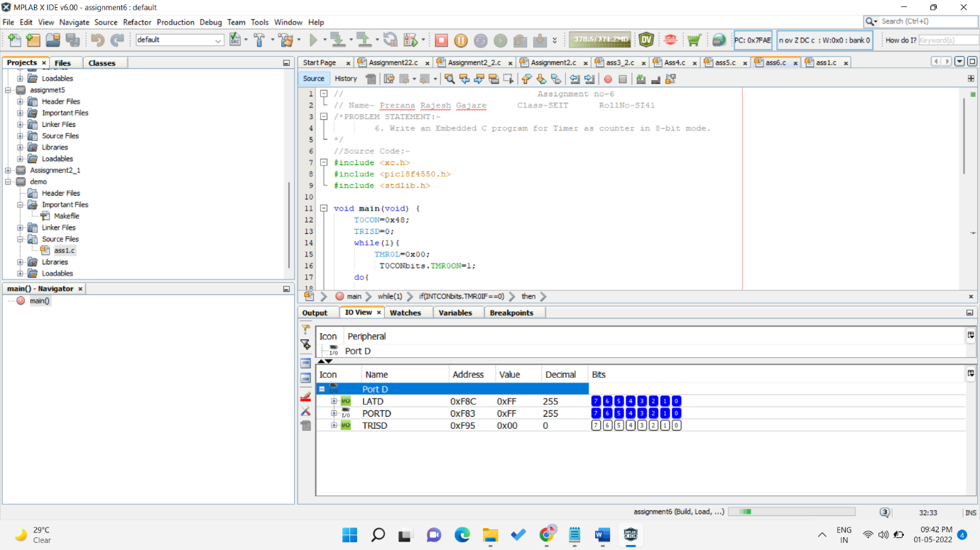

1. **PICSIM LAB OUTPUT**

